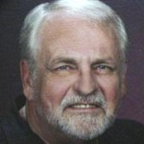
/Order Bob’s Book
Boiling the Frog
Get a signed copy for $10
Postpaid to U S addresses only
Send check or money order only to:
Bob Bandy
P O Box 696
Rancho Cordova, Ca. 956741
63+ articles - 155 pages – large format

